

**Presentation on Total Gaming Solution**

**Presented to,**

**Iftekharul Mobin,**

**Iqbal Hossain,**

**Department of Computer Science and Engineering.**

By

Arnab Barua- 15301012   
Atif Imtiaz- 14201015  
Ghalib Ashraf- 15301090

**Table of Contents**

Introduction  
Proposed System  
 Requirements  
 Functional and non-functional requirement  
 Function point and Gantt chart  
 Overview  
 Programming Language  
 Database  
 Other technologies  
 System Models  
Implementation Details  
Effort Breakdown of Members  
Conclusion

**Introduction**

In recent times, B2C or business-to-consumer e-commerce has grown into the most popular and prolific form of online trade. It is commerce between businesses and consumers. It is more commonly known as online retailing and involves customers purchasing goods and services online. Our purpose was to make such system, that can provide such service to a target audience and fulfil the demand of esports peripherals and necessities.

The goal is to reach the demands of ever growing esports fan and enthusiasts over one web-site. More and more Bangladeshi players are entering the multi-million-dollar Esports scene, and to help it grow and fulfil the needs of the esports player, our site will provide not only products, but also an interactive forum, written by esports player all over the world.

**Proposed System**

Since, the system is a web site, accessible from computer, laptops and mobile phones, we designed our system in the following manner and plan.

**A. Functional requirements**

1. Account Sign Up

1.1. Users can sign up as members or developers.

1.2. Each user will have their own transaction details.

1.3. Developers will have access to upload/modify game files to the server.

2. Marketplace

2.1 Users will be able to purchase games and peripherals.

2.2 Users will be able to search games by category.

2.3 Each transaction will have their own secured transaction (eg. PayPal, E-comm, etc) methods.

3. Game Database

3.1. Developers will have full access to any data related to the games for sale.

3.2. Users can access updates to existing games here.

3.3. Each product will have different unique ID and database.

4. Forum/ Community

4.1. Members/developers will be able to create forum regarding a game or product.

4.2. Users both buyers and sellers can form threads of comments.

5. Support

5.1. System will provide standard refund policy for games.

5.2. System will provide any support regarding E-commerce problems.

**B. Nonfunctional requirements**

1. Operational requirements

1.1. The system will run on windows, mac, android and ios environment.

1.2. The system will be able to create .doc, .txt, .docx, .pdf files

1.3. The system will be able to read from game files from the FTP Server.

1.4. The system will be able to work on any browser like Chrome, Firefox etc.

1.5. The system will be able to integrate threads or forums into existing database.

1.6. The system will be able to show user recommendations based on user preference history.

2. Performance requirements

2.1. Updates and bug-fixes for games must be provided as soon as developers release it.

2.2. The system should be accessible and available for use 24/7.

2.3. The system will have a backup as a maintenance page.

2.4. The response time between the users and the system should be 2-7 seconds.

2.5 The System will provide SEO for all the products on home and sub-pages.

3. Security requirements

3.1. Two-step authentication is a must for members and developers.

3.2. The system will provide account recovery system for users.

3.3. The System will provide bot detection for initial log in and sign ups.

4. Cultural and Political Requirements

4.1 The system can distinguish in different currencies.

4.2 The system complies with insurance industry standards for the sale of peripherals.

**FUNCTION POINT for TOTAL GAMING SOLUTION**

|  |  |  |  |  |  |
| --- | --- | --- | --- | --- | --- |
| Description |  | Complexity | | |  |
| Total Number | Low | Medium | High | Total |
| Inputs | 9 | 5X3 | 4X4 | X6 | 31 |
| Outputs | 6 | 4X4 | 2X5 | X7 | 26 |
| Queries | 8 | X3 | 6X4 | 2X6 | 36 |
| Files | 5 | 5X7 | X10 | X15 | 35 |
| Program Interface | 4 | 2X5 | 2X7 | X10 | 24 |
| TUFP |  |  |  |  | 152 |

|  |  |
| --- | --- |
| FUNCTION POINTS ESTIMATION | |
| DATA COMMUNICATIONS | 3 |
| HEAVY USE CONFIGURATION | 2 |
| TRANSACTION RATE | 4 |
| END-USER EFFICIENCY | 4 |
| COMPLEX PROCESSING | 2 |
| INSTALLATION EASE | 2 |
| MULTIPLE SITES | 1 |
| PERFORMANCE | 2 |
| DISTRIBUTED FUNCTIONS | 3 |
| ON-LINE DATA ENTRY | 4 |
| ON-LINE UPDATE | 4 |
| REUSABILITY | 2 |
| OPERATIONAL EASE | 3 |
| EXTENSIBILITY | 1 |
| PROJECT COMPLEXITY (PC) | 37 |

|  |  |
| --- | --- |
| FUNCTION POINT ESTIMATION | |
| PROCESSING COMPLEXITY(PC): | 37 |
| ADJUSTED PROCESSING COMPLEXITY (PCA) | 0.65+(0.01*37) = 1.02 |
| TOTAL ADJUSTED FUNCTION POINTS (TAFP) | 152* 1.02 = 155.04 |

Approximate number of line of codes per function point for HTML: 29  
Approximate number of line of codes per function point for PHP: 40  
Approximate number of line of codes per function point for CSS: 18

HTML= 48%; PHP= 22% & CSS=30%

Total lines of code for HTML: (48% of 152) *29 = 2115  
Total lines of code for PHP: (22% of 152) *20= 1003  
Total lines of code for CSS: (30% of 152) *18=821  
Total line of codes: 3939

Effort: 1.4*KLOC (Kilo Line of Code)  
=1.4 x 3.939=5.5146 person-months of effort

Schedule time(months) = 3.0 x (5.5146)1/3=5.300204

Therefore, 5.5146 person-month of effort would make this project complete under 5.3 months.

**Gantt Chart**

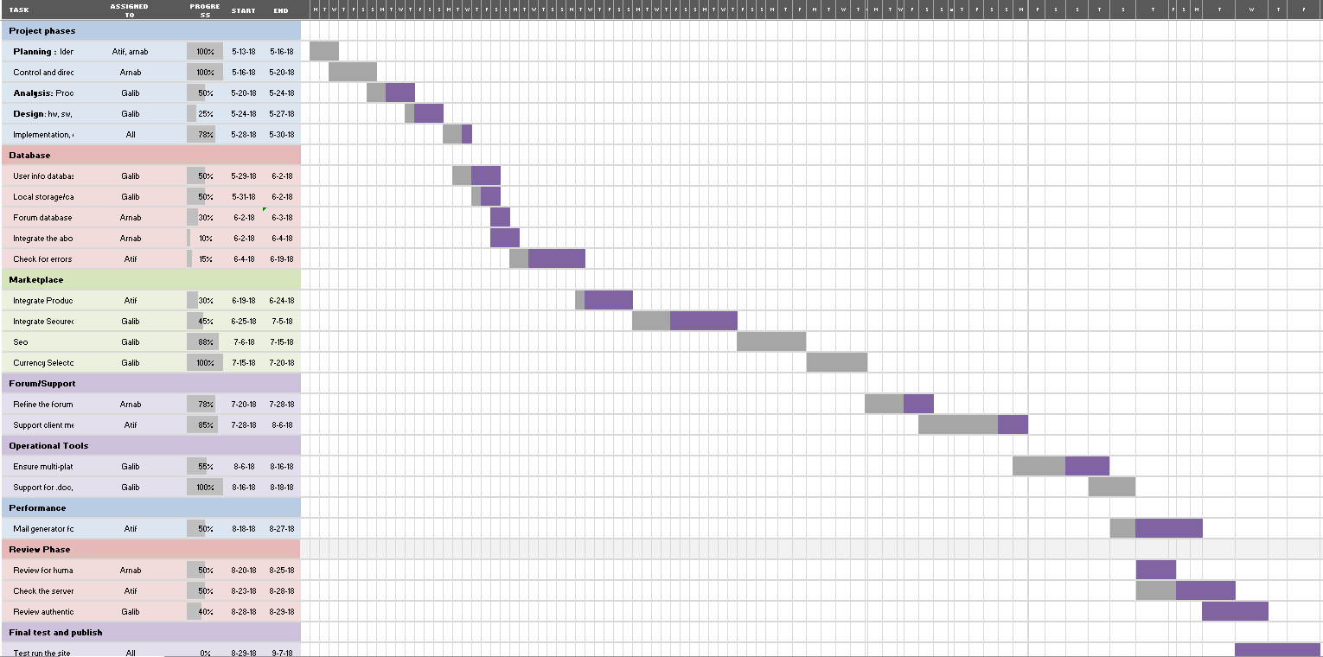

(File Uploaded to this link <https://drive.google.com/file/d/1T-6VNiMyEPQG3ihjF3dNLPMYEClCTeMt/view?usp=sharing>)

System Request Report

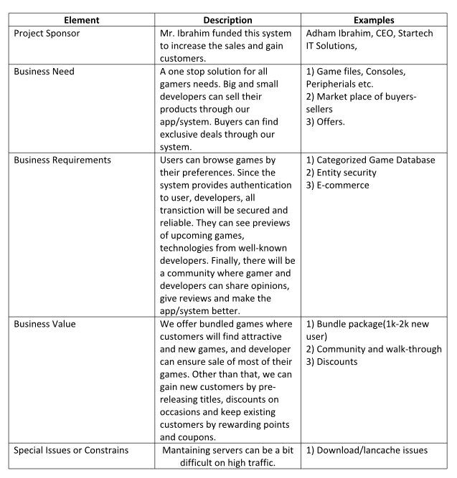

**BRIEF DESCRIPTION** Our project will offer an online platform for game developers to sell their games and for gamers to get their hands-on games easily without any hassle. We also include a peripheral and console shop along with a forum for discussions.

**MOTIVATION** Provide local game developers a platform to rise and motivate them into developing more games. There is a lack of online game shops in the country that addresses almost all virtual issues of gamers.

**PROJECT PHASES:**

**1. PLANNING**

**Identifying business value:** The business plans to address the lack of online game shops and capture the growing market of gaming peripherals through an easy to access online website.

**Develop work plan:**1. Create project plan   
2. Analyse market   
3. Contact game developers   
4. Conduct survey   
5. Hire developers   
6. Hire graphic designers   
7. Create marketing strategy

**Staff the project:**1. Administrators/Project Champion/Stakeholders   
2. Database resource collectors   
3. Database maintenance support   
4. Content Manager   
5. Forum Moderator   
6. Backend Developers   
7. Frontend Developers   
8. Graphic Designers

**2. ANALYSIS**

**Analysis of current system:** Current online shops which sell games and game peripherals do not exist in the country. So our system will aim to be a forerunner in this field and address the marketplace of gamers and game developers.

**Analysis of Proposed System:** Our system will provide game developers with tools to sell their games and monitor the sales and get insights and feedbacks. It will give each developer and customer their own secure accounts and include secure ecommerce platform since transaction of currency is involved. The system will have a database of games with the games on servers. It will also hold a database of physical products which the website will sell to increase revenue. There will be tools for content creator to easily update the databases.

**3. DESIGN Architectural Design:** The website will have a main landing page divided into a login/registration page which will direct to the main page which will have sections for browsing games or peripherals or an access link to the forum.

**Features:**● Database of games   
● Shop for gaming peripherals   
● Forum

**Software:** ● PhP/ HTML ● .NET ● Javascript ● Database (mysql)

**Overview**

**Programming Language:** Html5, Css, Bootstrap Framework, Php

**Database:** Local host  
**Other Technologies:** cPanel, Vista panel for hosting and test purpose

**System Models**

Use case & Activity Diagram  
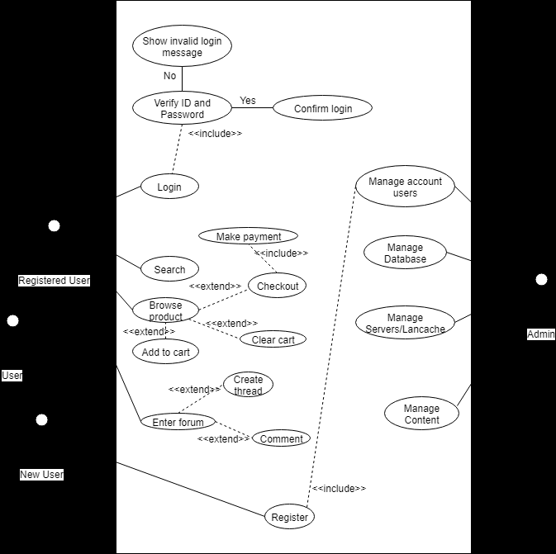

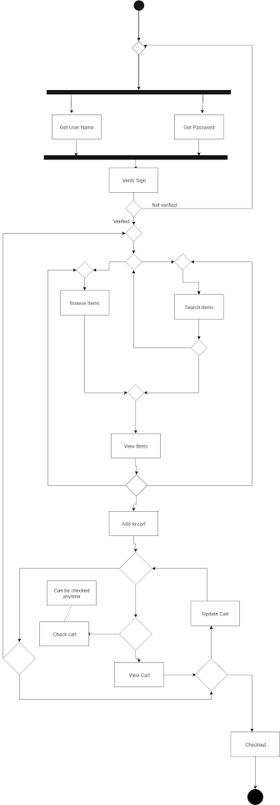Activity diagram

Sequence Diagram  
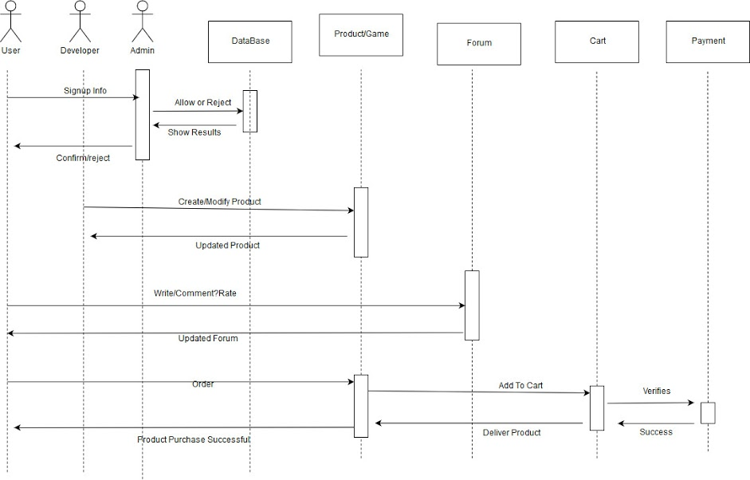

ER Diagram

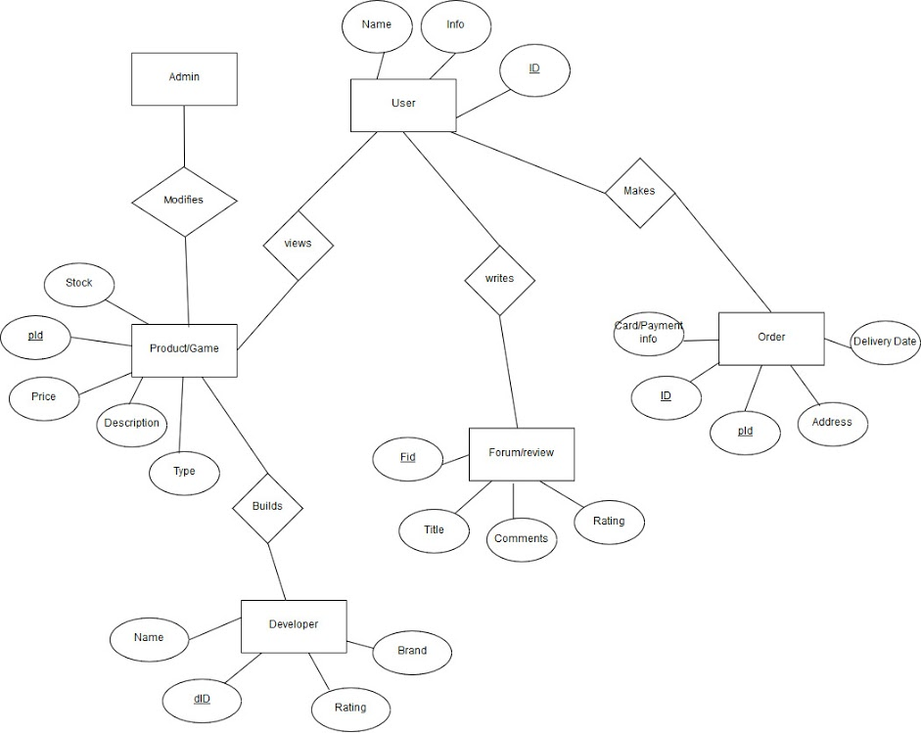

**Implementation Details:**

Our system will provide game developers with tools to sell their games and monitor the sales and get insights and feedbacks. It will give each developer and customer their own secure accounts and include secure ecommerce platform since transaction of currency is involved. The system will have a database of games with the games on servers. It will also hold a database of physical products which the website will sell to increase revenue. There will be tools for content creator to easily update the databases. Current online shops which sell games and game peripherals do not exist in the country. So, our system will aim to be a forerunner in this field and address the marketplace of gamers and game developers.

**Effort Breakdown of Members:**

Arnab, Atif and Ghalib, all three worked hard and accepted new challenges to make the system and give it a working phase.

**Conclusion**

Finally, we would like to thank our mentors, Mr. Iqbal Hossain and Mr. Iftekharul Mobin, without whom we would not be able to finish the presentation in such manner. Without their help, it would be still unknown to us, how to design and analyse a system.